# Inferential Statistics Analysis

In the data set, it is showing a relatively strong correlation between rented bike count, the target variable, and hour and temperature, the two predictive variables. Hence, the two features will be used when training the model.

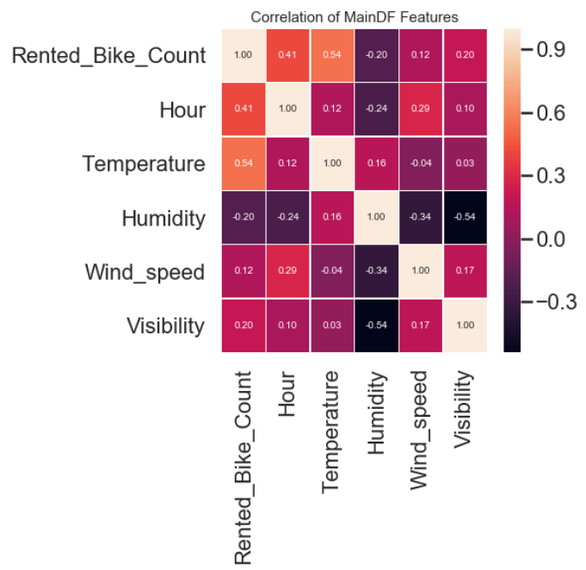

I am also interested in seeing whether the rental activities on holiday is similar to the non-holiday days. Hence, the Null hypothesis is the average of rental bike count on the holiday and the rental bike count on the non-holiday is the same. The alternative hypothesis then is the average of the bike counts are different. The t-value returns -7.59, indicating we reject the null hypothesis—the rental activities are quite different between holiday season and non-holiday season.

In addition to the holiday impact, I am also interested in the season impact to the rental bike activities, especially on summer and winter. The t-value returns 10.26, indicating we accept the null hypothesis—there is no significant difference between the rental activity in summer and in winter.